Patient:  WEST, Simon  E2448278 | Gender: | Male | Physician: | WONG Terry Dr
Patient:  WEST, Simon  E2448278 | DOB / Age: | 11/23/1975 | Operator: | DR JAFAR JAFARI
Patient:  WEST, Simon  E2448278 | Height: | 5 ft 7 in | Referring Physician:
Patient:  WEST, Simon  E2448278 | Procedure: | HIGH RESOLUTION MANOMETRY | Examination Date: | 01/06/2020

Swallow Composite (mean of 10 swallows) | Resting Pressure Profile & Anatomy
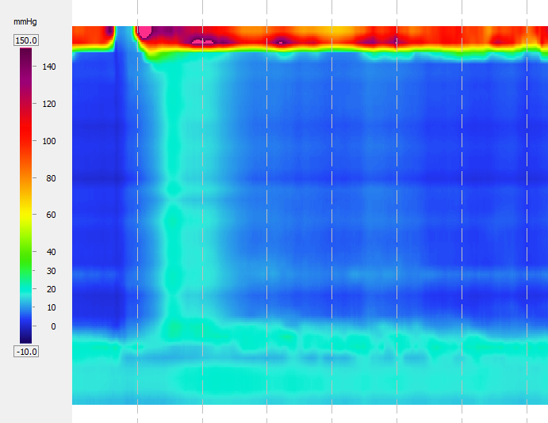 | 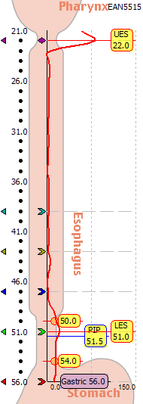 | Basal Pressures*  LES, respiratory mean(mmHg) 10.8 (13-43)  UES mean(mmHg) 79.7 (34-104)  Anatomy*  LES proximal(cm) 50.0  LES intraabdominal(cm) 2.5  Esophageal length(cm) 29.0  Hiatal hernia No
Motility*  Dist. wave amplitude(mmHg) N/A (43-152)  Wave dur. @ LES -3.0 & 7.0(s) N/A (2.7-5.4)  Onset vel. (LES -11.0 to -3.0)(cm/s) N/A (2.8-6.3)  Percent peristaltic(%) 0  Percent simultaneous(%) 0 (≤10%)  Percent failed(%) 100 (0%)  Distal contr. integral(mmHg-cm-s) N/A (500-5000) |  | Residual Pressures*  LES (mean)(mmHg) 3.8 (<15.0)  UES (mean)(mmHg) 4.5 (<12.0)
*Notes. Motility values are mean among swallows; Normal values in (xxx.x): Simultaneous contractions: Velocity > 8.0 cm/s; eSlv: eSleeve; 3SN, IRP, DCI, IBP - See manual definitions

Lower Esophageal Sphincter Region |  | Normal | Esophageal Motility |  | Normal
Landmarks |  |  | Number of swallows evaluated | 10
Proximal LES (from nares)(cm) | 50.0 |  | Evaluated @ 3.0 - 11.0 above LES
LES length(cm) | 4.0 | 2.7-4.8 | Peristaltic (velocity ≤ 6.25 cm/s)(%) | 0
Esophageal length (LES-UES centers)(cm) | 29.0 |  | Simultaneous (vel. ≥ 6.25 cm/s)(%) | 0 | ≤10%
Intraabdominal LES length(cm) | 2.5 |  | Failed(%) | 100 | 0%
Hiatal hernia? | No |  | Evaluated @ 3.0 & 7.0 above LES
LES Pressures |  |  | Mean wave amplitude(mmHg) | N/A | 43-152
Pressure meas. method | eSleeve,IRP |  | Mean wave duration(s) | N/A | 2.7-5.4
Basal (respiratory min.)(mmHg) | 4.0 | 4.8-32.0 | Double-peaked waves(%) | N/A | ≤15%
Basal (respiratory mean)(mmHg) | 10.8 | 13-43 | Triple-peaked waves(%) | N/A | 0%
Residual (mean)(mmHg) | 3.8 | <15.0 | Velocity (11.0-3.0 above LES)(cm/s) | N/A | 2.8-6.3
 |  |  | High Resolution Parameters
 |  |  | Distal contractile integral(mean)(mmHg-cm-s) | N/A | 500-5000
 |  |  | Contractile front velocity(cm/s) | N/A | <9.0
 |  |  | Intrabolus pressure (@LESR)(mmHg) | N/A | <8.4
 |  |  | Intrabolus pressure (avg max)(mmHg) | N/A | <17.0
 |  |  | Chicago Classification
 |  |  | Distal latency | N/A
 |  |  | % failed (Chicago Classification) | 100
 |  |  | % panesophageal pressurization | 0
 |  |  | % premature contraction | 0
 |  |  | % rapid contraction | 0
 |  |  | % large breaks | 0
 |  |  | % small breaks | 0
Upper Esophageal Sphincter |  | Normal | Pharyngeal / UES Motility |  | Normal
Mean basal pressure(mmHg) | 79.7 | 34-104 | No. swallows evaluated | 10
Mean residual pressure(mmHg) | 4.5 | <12.0 | Evaluated @ 3.0 & N/A above UES
 |  |  | Mean peak pressure(mmHg) | 54.1

Procedure

Indications

Interpretation / Findings

Impressions

Swallow #1  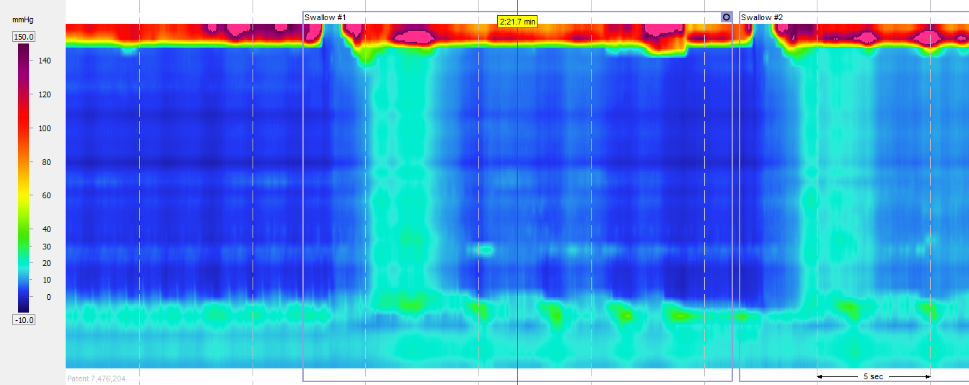 | Swallow #2  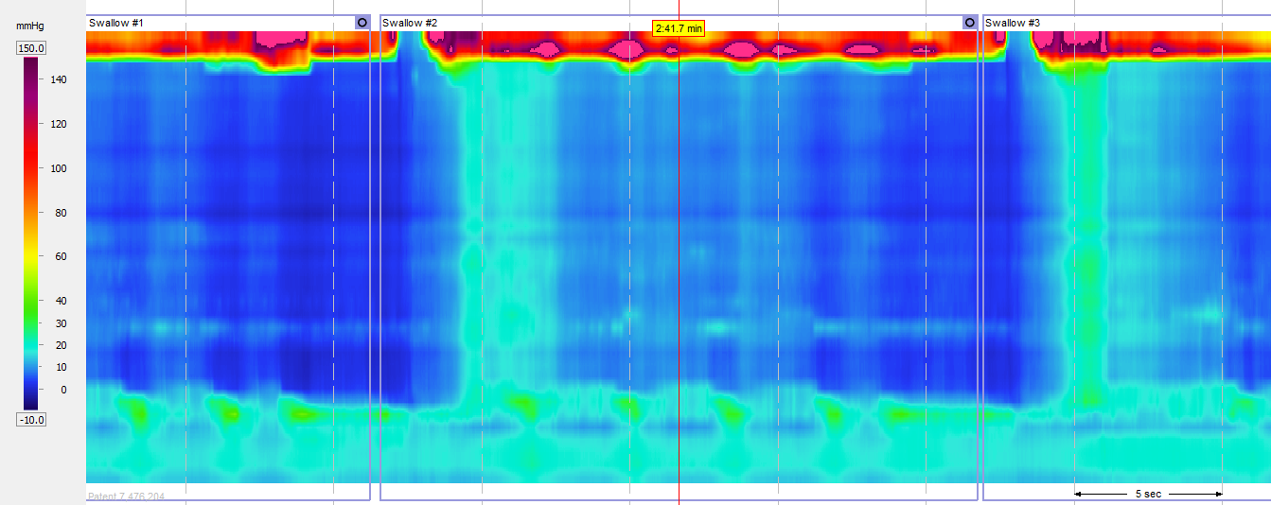
Swallow #3  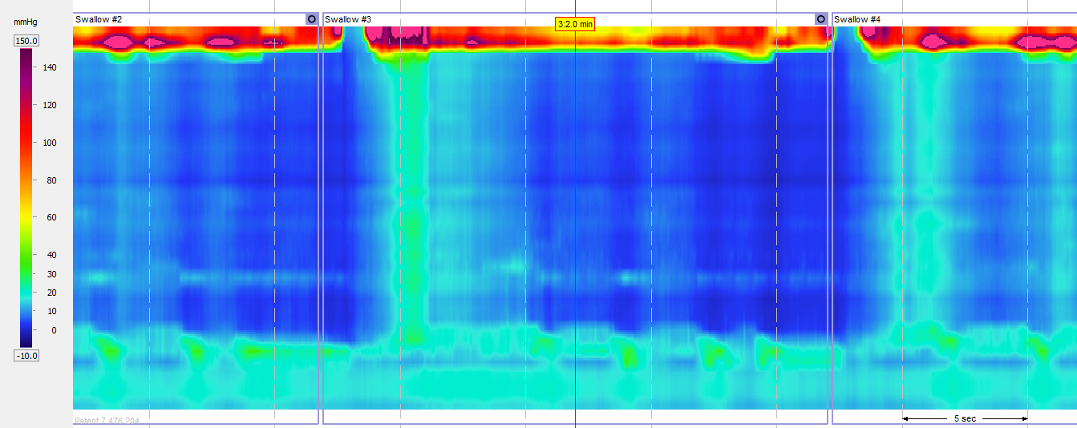 | Swallow #4  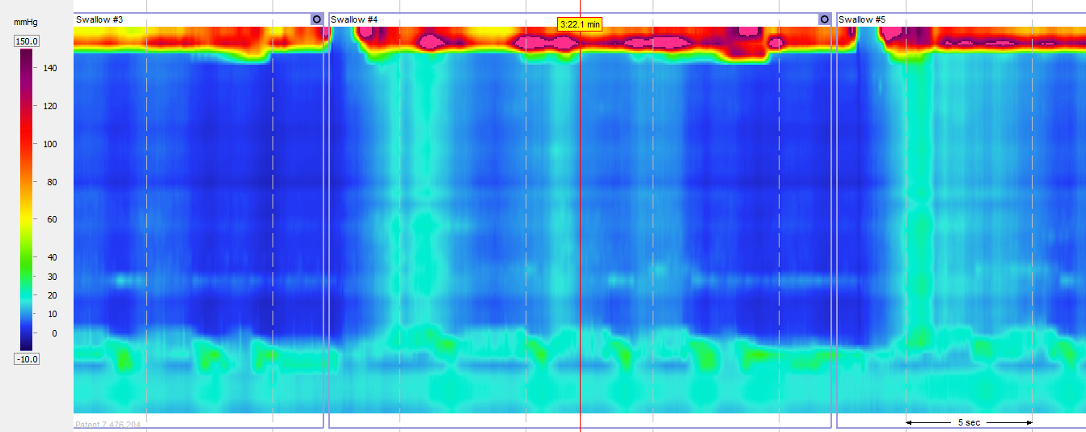
Swallow #5  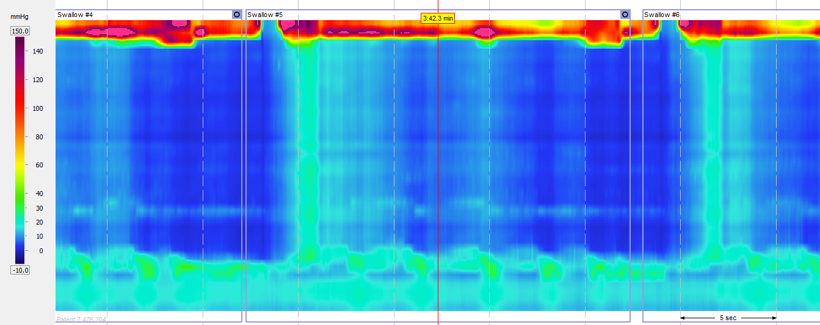 | Swallow #6  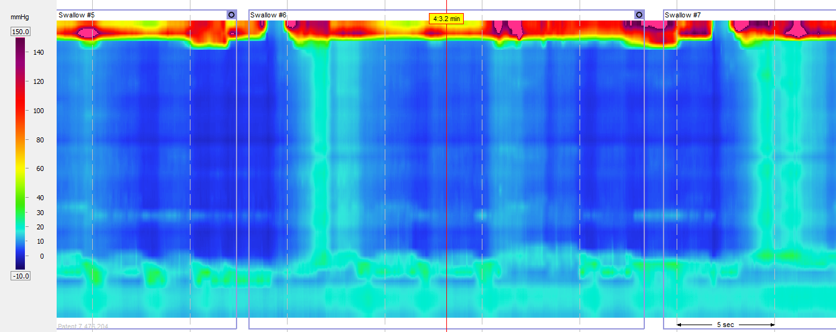
Swallow #7  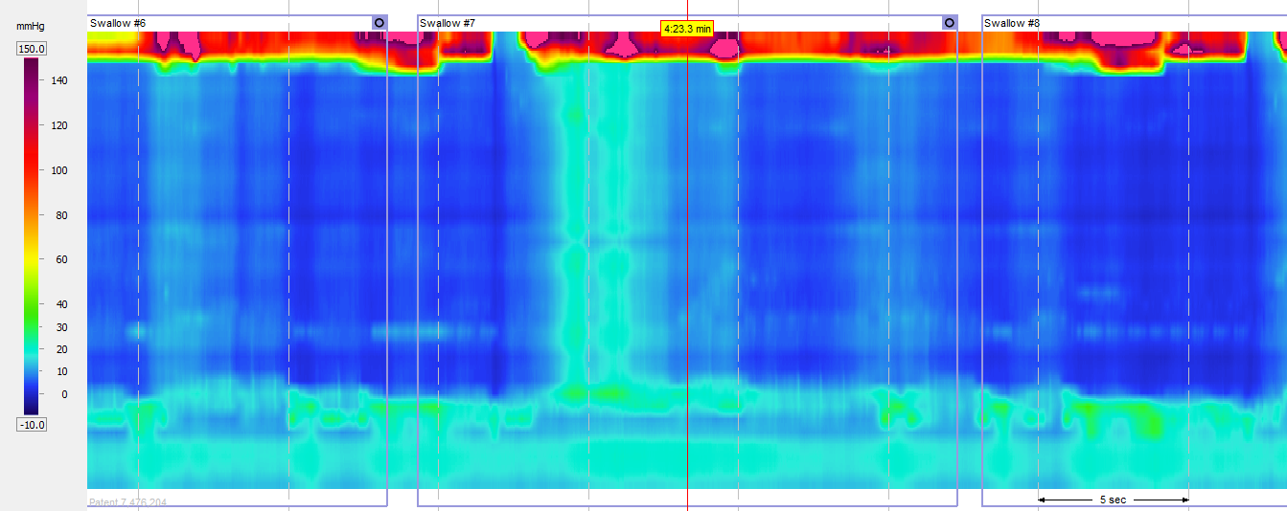 | Swallow #8  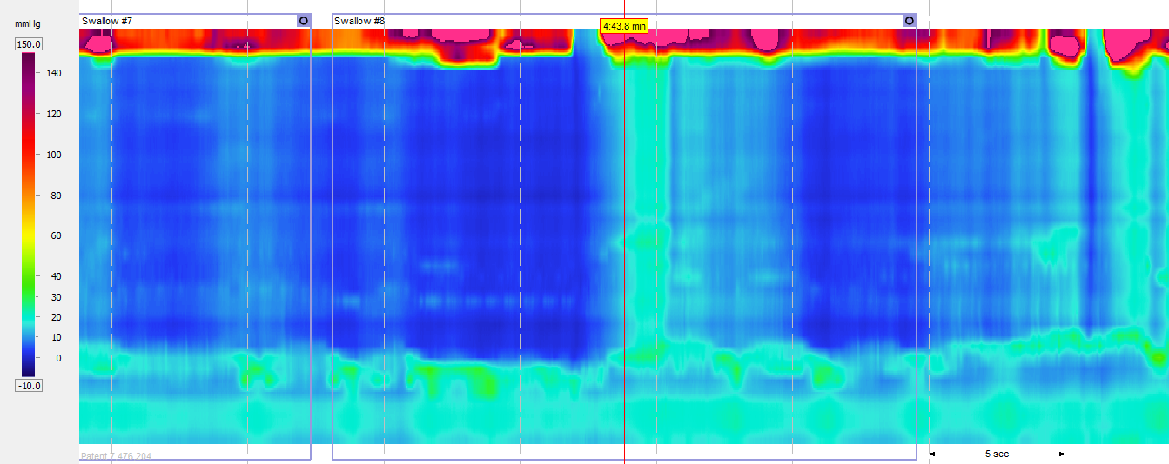
Swallow #9  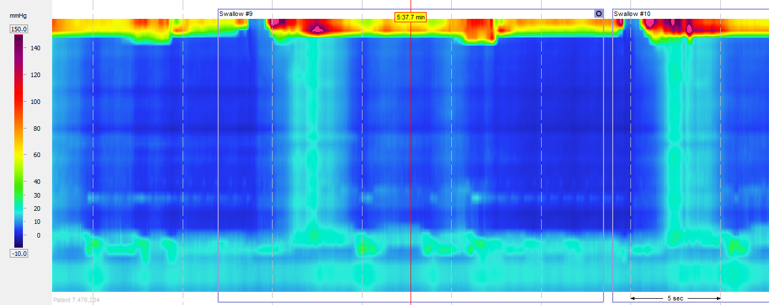 | Swallow #10  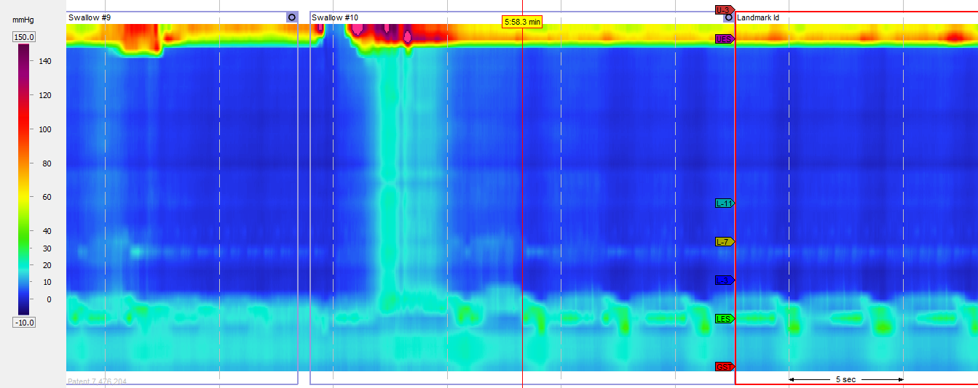
Landmark Id

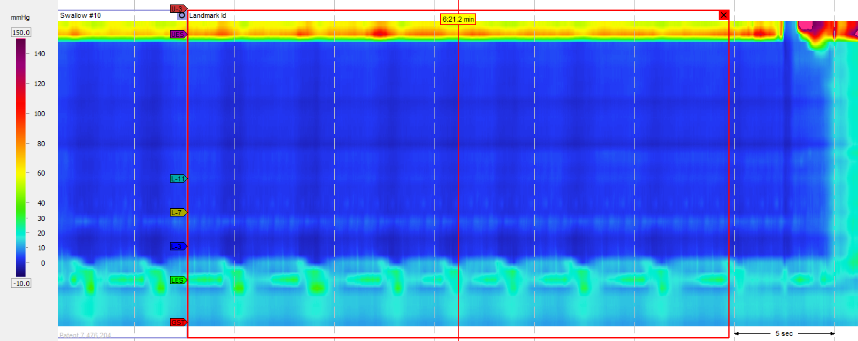

 | Normal | Group / Mean | Swal.  #1 | Swal.  #2 | Swal.  #3 | Swal.  #4 | Swal.  #5 | Swal.  #6 | Swal.  #7 | Swal.  #8 | Swal.  #9 | Swal.  #10
ESOPHAGEAL MOTILITY
LES residual pressure (mmHg) | <15.0 | 3.8 | 3.7 | 2.8 | 3.7 | 4.0 | 4.3 | 4.6 | 3.6 | 2.9 | 3.9 | 4.2
Classic ManoView
Wave amplitude (mean, 3.0 & 7.0 above LES) (mmHg) | 43-152 | N/A | N/A | N/A | N/A | N/A | N/A | N/A | N/A | N/A | N/A | N/A
Wave duration (mean at 3.0 & 7.0 above LES) (sec) | 2.7-5.4 | N/A | N/A | N/A | N/A | N/A | N/A | N/A | N/A | N/A | N/A | N/A
Onset velocity (between 11.0 & 3.0 above LES) (cm/s) | 2.8-6.3 | N/A | N/A | N/A | N/A | N/A | N/A | N/A | N/A | N/A | N/A | N/A
% peristaltic (between 11.0 & 3.0 above LES) |  | 0 | 0 | 0 | 0 | 0 | 0 | 0 | 0 | 0 | 0 | 0
% simultaneous (between 11.0 & 3.0 above LES) | ≤10% | 0 | 0 | 0 | 0 | 0 | 0 | 0 | 0 | 0 | 0 | 0
% failed (between 11.0 & 3.0 above LES) | 0% | 100 | 1 | 1 | 1 | 1 | 1 | 1 | 1 | 1 | 1 | 1
Double peaked swallows (% of Swallows) | ≤15% | N/A | N/A | N/A | N/A | N/A | N/A | N/A | N/A | N/A | N/A | N/A
Triple peaked swallows (% of Swallows) | 0% | N/A | N/A | N/A | N/A | N/A | N/A | N/A | N/A | N/A | N/A | N/A
High Resolution Parameters
Distal contractile integral (mmHg-cm-s) | 500-5000 | N/A | N/A | N/A | N/A | N/A | N/A | N/A | N/A | N/A | N/A | N/A
Contractile front velocity (cm/s) | <9.0 | N/A | N/A | N/A | N/A | N/A | N/A | N/A | N/A | N/A | N/A | N/A
Intrabolus pressure (@LESR,mmHg) | <8.4 | N/A | N/A | N/A | N/A | N/A | N/A | N/A | N/A | N/A | N/A | N/A
Intrabolus pressure (avg max,mmHg) | <17.0 | N/A | N/A | N/A | N/A | N/A | N/A | N/A | N/A | N/A | N/A | N/A
Chicago Classification
Distal latency (sec) |  | N/A | N/A | N/A | N/A | N/A | N/A | N/A | N/A | N/A | N/A | N/A
% failed (Chicago Classification) |  | 100 | 1 | 1 | 1 | 1 | 1 | 1 | 1 | 1 | 1 | 1
% panesophageal pressurization |  | 0 | 0 | 0 | 0 | 0 | 0 | 0 | 0 | 0 | 0 | 0
% premature contraction |  | 0 | 0 | 0 | 0 | 0 | 0 | 0 | 0 | 0 | 0 | 0
% rapid contraction |  | 0 | 0 | 0 | 0 | 0 | 0 | 0 | 0 | 0 | 0 | 0
% large breaks |  | 0 | 0 | 0 | 0 | 0 | 0 | 0 | 0 | 0 | 0 | 0
% small breaks |  | 0 | 0 | 0 | 0 | 0 | 0 | 0 | 0 | 0 | 0 | 0
UES / PHARYNGEAL MOTILITY
UES residual pressure (mean) (mmHg) | <12.0 | 4.5 | 3.8 | 4.4 | 5.8 | 3.7 | 5.1 | 5.5 | 5.6 | 6.0 | 2.8 | 2.8

